Uninstalling OUD is very easy. Follow the below steps.

1. Run the uninstall utility for the directory server.
2. In Instant path ./uninstall

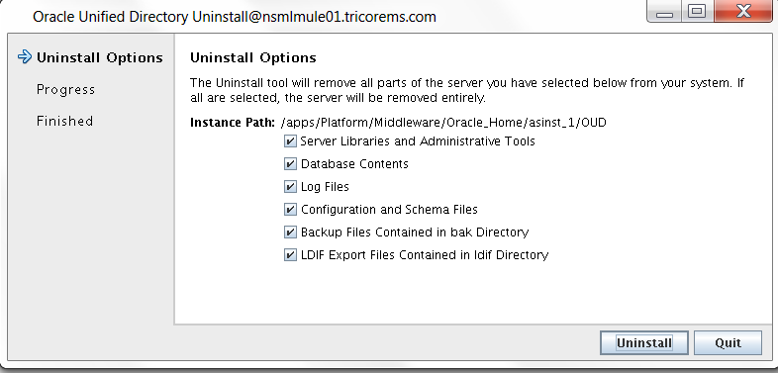

1. Verify that all checkboxes are ticked and click Uninstall.

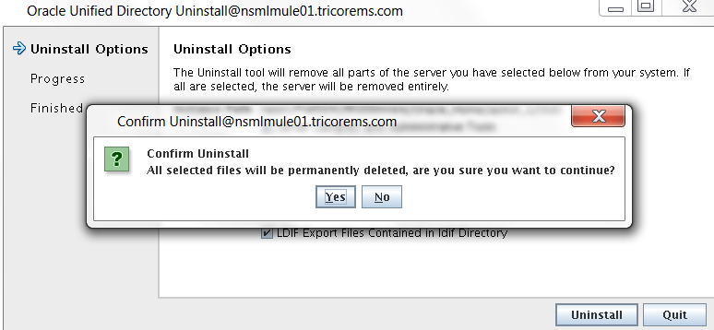

1. Uninstallation complete. OUD instance will delete automatically

